# Digital Control: Exercise 6a

Xu Fei feixu12@student.hh.se

## Basic theory

1. **Pendulum dynamics**

The geometric model of pendulum is shown in figure 1.1.

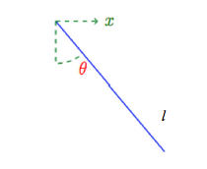

Figure 1.1 Geometric model of pendulum

Consider the pendulum above. If the length of the pendulum is $l$ and a point mass of weight $m$ is hanging at its tip, the Newton force law, in tangential direction of rotation, gives (neglecting friction temporarily):

$$-l\ddot{θ}m=mg\sin{θ}+ml\cos{θ}∙\ddot{x}$$

Assume a servomotor with the simplified dynamics can control the position:

$$\dot{x}=u$$

Where $u$ is the input (control variable) to the servo. Let $g_{l}=g/l$ and also introduce a friction that depends on rotational velocity then:

$$\ddot{θ}=-g_{l}\sin{θ-d}\dot{θ}-\cos{θ}∙\dot{u}$$

This pendulum dynamics has been implemented in *PendulumDamp.sq* where it is animated. I should implement two controllers. The first controller should damp the pendulum dynamics when it is hanging down. The second controller should stabilize the pendulum when it is inverted. Thus, the pendulum can be considered as two different processes, one then it is hanging down and another one is inverted.

1. **Linearization**

There are two balance states for the pendulum, $θ=0$ and $θ=π$. The first one is stable and another one is unstable. The linearized dynamics consider deviation from equilibrium. Let $y=θ-θ_{0}$ and linearize around $θ_{0}$.

$$\sin{θ}≈\sin{θ_{0}}+\frac{d}{dθ}\sin{θ_{0}}\left(θ-θ_{0}\right)=\sin{θ_{0}}+\cos{θ_{0}}y$$

$$\cos{θ}≈\cos{θ_{0}}+\frac{d}{dθ}\cos{θ_{0}}\left(θ-θ_{0}\right)=\cos{θ_{0}}-\sin{θ_{0}}y$$

1. **Down**

­­For $θ_{0}=0$ if follows that $\sin{θ}=y$ and $\cos{θ}=1$ giving:

$$\ddot{y}={-g}_{l}y-d\dot{y}-\dot{u}$$

And the transfer function $(Y\left(s\right)=G (s) U (s))$ is:

$$G \left(s\right)=\frac{-s}{s^{2}+ds{+g}_{l}}$$

The poles of the continuous-time system are $p_{1,2}=-d/2∓i\sqrt{g_{l}-d^{2}/4}$, which are both in the left half plane (stable) because of the friction term $d>0$. The less friction the more oscillatory are the poles. Feedback can be used to make the system less oscillatory despite the badly dampened poles.

1. **Up**

For $θ_{0}=π$ if follows that $\sin{θ}=-y$ and $\cos{θ}=-1$ giving:

$$\ddot{y}=g_{l}y-d\dot{y}+\dot{u}$$

And the transfer function is

$$G \left(s\right)=\frac{s}{s^{2}+ds{-g}_{l}}$$

This system has one unstable pole $p_{1}=-d/2+i\sqrt{g_{l}-d^{2}/4}>0$ and one stable pole $p_{2}=-d/2+i\sqrt{g_{l}-d^{2}/4}<0$. The system is therefore unstable and any small perturbation will make the pendulum fall down. Feedback is needed in order to stabilize this system.

## Sampling

Calculate the sampled systems using zero-order-hold sampling for the two cases above. Thus, calculate the discrete-time system.

$$A(q^{-1})y(k)=B(q^{-1})u(k)$$

Use the parameter values $g_{l}=0.981$, $d=0.1$ and sampling interval $h=1s$.

For the case when pendulum is

1. Down (stable but badly dampened).

The continuous function is:

$$G \left(s\right)=\frac{-s}{s^{2}+ds{+g}_{l}}=-\frac{s}{s^{2}+0.1s+0.981}$$

$$→G \left(s\right)=-\frac{s}{[s-\left(-0.0500+0.9892i\right)]×[s-\left(-0.0500-0.9892i\right)]}$$

$$→G \left(s\right)=\frac{-0.5-0.0253i}{[s+0.0500-0.9892i]}+\frac{-0.5+0.0253i}{[s+0.0500+0.9892i]}$$

So we can regard $G_{1} \left(s\right)=\frac{-0.5-0.0253i}{[s—(-0.0500+0.9892i)]}$ and $G_{2} \left(s\right)=\frac{-0.5+0.0253i}{[s- (-0.0500-0.9892i)]}$

As we already know from exercise 5,

$$\left\{\begin{aligned}λ_{1}=e^{p_{1}h}=e^{p_{1}}=e^{(-0.0500+0.9892i)}≈0.5226 + 0.7948i \\ b_{1}=\frac{λ_{1}-1}{p_{1}}=\frac{e^{(-0.0500+0.9892i)}-1}{0.0500-0.9892i}≈0.8258 + 0.4409i\end{aligned}\right.$$

$$\left\{\begin{aligned}λ_{2}=e^{p_{2}h}=e^{p_{2}}=e^{\left(-0.0500-0.9892i\right)}≈0.5226 - 0.7948i \\ b_{2}=\frac{λ_{2}-1}{p_{2}}=\frac{e^{\left(-0.0500-0.9892i\right)}-1}{-0.0500-0.9892i}≈0.8258 - 0.4409i\end{aligned}\right.$$

$$H_{1} \left(q^{-1}\right)=\frac{b_{1}}{1-e^{p_{1}}q^{-1}}q^{-1}=\frac{0.8258 + 0.4409i}{1-e^{(-0.0500-0.9892i)}q^{-1}}q^{-1}$$

$$H_{2} \left(q^{-1}\right)=\frac{b_{2}}{1-{e^{p_{2}}q}^{-1}}q^{-1}=\frac{0.8258 - 0.4409i}{1-e^{\left(-0.0500-0.9892i\right)}q^{-1}}q^{-1}$$

$$H\left(q^{-1}\right)=\left(-0.5-0.0253i\right)H_{1} \left(q^{-1}\right)+\left(-0.5+0.0253i\right)H_{2} \left(q^{-1}\right)$$

$$→H\left(q^{-1}\right)=\frac{-0.4017 – 0.2413i}{1-e^{\left(0.0500-0.9892i\right)}q^{-1}}q^{-1}+\frac{-0.4017 + 0.2413i}{1-e^{\left(-0.0500-0.9892i\right)}q^{-1}}q^{-1}$$

$$→H\left(q^{-1}\right)=\frac{(-0.4017 – 0.2413i)q^{-1}}{1-(0.5226 + 0.7948i)q^{-1}}+\frac{(-0.4017+ 0.2413i)q^{-1}}{1-(0.5226 - 0.7948i{)q}^{-1}}$$

$$→H\left(q^{-1}\right)=\frac{-0.8034q^{-1}+\left(0.4017- 0.1932i\right)q^{-2}+(0.4017 + 0.1932i)q^{-2}}{1-1.1001q^{-1}+0.9048q^{-2}}$$

$$→H\left(q^{-1}\right)=\frac{-0.8034q^{-1}+0.8034q^{-2}}{1-1.0452q^{-1}+0.9048q^{-2}}$$

1. Up (unstable).

The continuous function is:

$$G \left(s\right)=\frac{s}{s^{2}+ds{-g}_{l}}=\frac{s}{s^{2}+0.1s-0.981}$$

$$→G \left(s\right)=-\frac{s}{[s+1.0417]×[s-0.9417]}$$

$$→G \left(s\right)=\frac{0.5252}{[s+1.0417]}+\frac{0.4748}{[s-0.9417]}$$

So we can regard $G_{1} \left(s\right)=\frac{0.4748}{[s-0.9417]}$ and $G_{2} \left(s\right)=\frac{0.5252}{[s+1.0417]}$

$$\left\{\begin{aligned}λ_{1}=e^{p_{1}h}=e^{p_{1}}=e^{-1.0417}≈0.3529 \\ b_{1}=\frac{λ_{1}-1}{p_{1}}=\frac{e^{-1.0417}-1}{-1.0417}≈0.6212\end{aligned}\right.$$

$$\left\{\begin{aligned}λ_{2}=e^{p_{2}h}=e^{p_{2}}=e^{0.9417}≈2.5643 \\ b_{2}=\frac{λ_{2}-1}{p_{2}}=\frac{e^{0.9417}-1}{0.9417}≈1.6611\end{aligned}\right.$$

$$H_{1} \left(q^{-1}\right)=\frac{b_{1}}{1-e^{p_{1}}q^{-1}}q^{-1}=\frac{0.6212}{1-e^{-1.0417}q^{-1}}q^{-1}$$

$$H_{2} \left(q^{-1}\right)=\frac{b_{2}}{1-{e^{p_{2}}q}^{-1}}q^{-1}=\frac{1.6611}{1-e^{0.9417}q^{-1}}q^{-1}$$

$$H\left(q^{-1}\right)=0.5252H_{1} \left(q^{-1}\right)+0.4748H_{2} \left(q^{-1}\right)$$

$$→H\left(q^{-1}\right)=\frac{0.3263}{1-e^{-1.0417}q^{-1}}q^{-1}+\frac{0.7887}{1-e^{0.9417}q^{-1}}q^{-1}$$

$$→H\left(q^{-1}\right)=\frac{0.3263q^{-1}}{1-0.3529q^{-1}}+\frac{0.7887q^{-1}}{1-2.5643q^{-1}}$$

$$→H\left(q^{-1}\right)=\frac{1.1150q^{-1}-1.1150q^{-2}}{1-2.9172q^{-1}+0.9050q^{-2}}$$

## Estimation

1. Perform an identification experiment.

Then I manually the mouse in signal window and try to keep $u=0$ and $mean (u) ≈0$, for the entire excitation.

Table 3.1 Samples

|  |  |  |
| --- | --- | --- |
| 7558.3098 | -4.0807e-3 | 1.1313e-2 |
| 7559.3299 | -4.0807e-3 | 1.7805e-2 |
| 7560.4312 | -4.0807e-3 | 6.5319e-3 |
| 7561.4512 | -4.0807e-3 | -9.2443e-3 |
| 7562.5302 | -4.0807e-3 | -1.5134e-2 |
| 7563.5512 | -4.0807e-3 | -6.2986e-3 |
| 7564.5711 | -4.0807e-3 | 7.2923e-3 |
| 7565.6711 | 3.1942e-2 | 1.2975e-2 |
| 7566.7112 | 3.1942e-2 | -2.217e-2 |
| 7567.7701 | 1.9935e-2 | -3.6548e-2 |
| 7568.8695 | 1.9935e-2 | -3.7881e-3 |
| 7569.9694 | -4.0807e-3 | 3.0499e-2 |
| 7571.0695 | -4.0807e-3 | 4.9358e-2 |
| 7572.1091 | -4.0807e-3 | 2.0774e-2 |
| 7573.1293 | -4.0807e-3 | -2.3434e-2 |
| 7574.191 | -4.0807e-3 | -4.2354e-2 |
| 7575.211 | -4.0807e-3 | -2.0344e-2 |
| 7576.2492 | -4.0807e-3 | 1.8258e-2 |
| 7577.3109 | -4.0807e-3 | 3.6246e-2 |
| 7578.3709 | -4.0807e-3 | 1.78e-2 |
| 7579.4508 | -4.0807e-3 | -1.6317e-2 |
| 7580.4894 | -4.0807e-3 | -3.0922e-2 |
| 7581.4908 | -4.0807e-3 | -1.6565e-2 |
| 7582.5908 | -4.0807e-3 | 1.3115e-2 |
| 7583.6108 | 7.9269e-3 | 2.6391e-2 |
| 7584.6298 | 7.9269e-3 | 5.7808e-3 |
| 7585.6506 | 7.9269e-3 | -1.909e-2 |
| 7586.6691 | -1.6088e-2 | -2.4526e-2 |
| 7587.7706 | -1.6088e-2 | 1.3491e-2 |
| 7588.8306 | 7.9269e-3 | 3.5795e-2 |
| 7589.9306 | 7.9269e-3 | 1.4074e-3 |
| 7590.989 | -1.6088e-2 | -3.2249e-2 |
| 7591.9906 | -1.6088e-2 | -1.4877e-2 |
| 7593.0088 | 1.9935e-2 | 1.6281e-2 |
| 7594.0504 | -1.6088e-2 | 2.1961e-3 |
| 7595.069 | -1.6088e-2 | 1.1774e-2 |
| 7596.169 | -1.6088e-2 | 1.2719e-2 |
| 7597.269 | -1.6088e-2 | 6.1661e-4 |
| 7598.3288 | -1.6088e-2 | -1.0613e-2 |
| 7599.3504 | 1.9935e-2 | -1.0813e-2 |
| 7600.4695 | 1.9935e-2 | -2.935e-2 |
| 7601.51 | 7.9269e-3 | -2.0081e-2 |
| 7602.5292 | -4.0807e-3 | 1.5362e-2 |
| 7603.5897 | -4.0807e-3 | 4.4234e-2 |
| 7604.6093 | -4.0807e-3 | 3.037e-2 |
| 7605.6103 | -4.0807e-3 | -8.4666e-3 |
| 7606.6288 | 7.9269e-3 | -3.6517e-2 |
| 7607.7101 | 7.9269e-3 | -3.7333e-2 |
| 7608.7693 | 7.9269e-3 | -3.1212e-3 |
| 7609.7902 | 7.9269e-3 | 2.9863e-2 |
| 7610.8299 | 7.9269e-3 | 3.2714e-2 |
| 7611.89 | 7.9269e-3 | 4.4443e-3 |
| 7612.929 | 7.9269e-3 | -2.4837e-2 |
| 7613.9701 | 1.9935e-2 | -2.8333e-2 |
| 7615.0892 | 7.9269e-3 | -1.2798e-2 |
| 7616.1285 | -4.0807e-3 | 2.1081e-2 |
| 7617.1487 | -4.0807e-3 | 4.2469e-2 |
| 7618.1884 | -4.0807e-3 | 2.4362e-2 |
| 7619.2296 | -1.6088e-2 | -1.4471e-2 |
| 7620.3083 | 7.9269e-3 | -2.673e-2 |
| 7621.3499 | -4.0104e-2 | -2.9709e-2 |
| 7622.4299 | -4.0807e-3 | 3.1938e-2 |
| 7623.4679 | -4.0807e-3 | 3.259e-2 |
| 7624.4683 | -4.0807e-3 | 1.3212e-3 |
| 7625.5098 | 1.9935e-2 | -2.8838e-2 |
| 7626.5483 | 1.9935e-2 | -4.7834e-2 |
| 7627.6083 | 3.1942e-2 | -2.2253e-2 |
| 7628.7089 | 3.1942e-2 | 1.3803e-2 |
| 7629.7278 | 1.9935e-2 | 3.0869e-2 |
| 7630.7679 | 7.9269e-3 | 2.755e-2 |
| 7631.7897 | 7.9269e-3 | 9.8872e-3 |
| 7632.8079 | 7.9269e-3 | -1.3748e-2 |
| 7633.8097 | 7.9269e-3 | -2.2912e-2 |
| 7634.8696 | 7.9269e-3 | -1.0309e-2 |
| 7635.9683 | 7.9269e-3 | 1.1503e-2 |
| 7637.0296 | -4.0807e-3 | 1.9461e-2 |
| 7638.069 | -4.0807e-3 | 1.7608e-2 |
| 7639.1696 | -4.0807e-3 | -3.5985e-4 |
| 7640.2077 | -4.0807e-3 | -1.5611e-2 |
| 7641.2086 | 7.9269e-3 | -1.5324e-2 |
| 7642.2295 | 7.9269e-3 | -1.0645e-2 |
| 7643.2694 | 7.9269e-3 | 2.2436e-3 |
| 7644.2891 | 7.9269e-3 | 1.1708e-2 |
| 7645.3091 | -2.8096e-2 | 9.8214e-3 |
| 7646.4087 | -2.8096e-2 | 2.7259e-2 |
| 7647.4684 | -2.8096e-2 | 1.9169e-2 |
| 7648.5094 | -2.8096e-2 | -5.934e-3 |
| 7649.6095 | -4.0807e-3 | -2.3389e-2 |
| 7650.7076 | -4.0807e-3 | -3.4416e-2 |
| 7651.8093 | -4.0807e-3 | -1.1407e-2 |
| 7652.8479 | -4.0807e-3 | 1.9429e-2 |
| 7653.8683 | -4.0807e-3 | 2.9433e-2 |
| 7654.9082 | -4.0807e-3 | 1.1711e-2 |
| 7655.9883 | -4.0807e-3 | -1.5893e-2 |
| 7657.0282 | -4.0807e-3 | -2.5169e-2 |
| 7658.0482 | -4.0807e-3 | -1.0748e-2 |
| 7659.0882 | -4.0807e-3 | 1.2225e-2 |
| 7660.1282 | -4.0807e-3 | 2.1652e-2 |
| 7661.1881 | -4.0807e-3 | 9.808e-3 |
| 7662.2281 | -4.0807e-3 | -9.8816e-3 |

And I use these data to calculate $θ$, then we can get:

$$th=\left({\begin{aligned}-0.9135 \\ 0.9809\end{aligned} \atop \begin{aligned}0.7463 \\ -0.7723\end{aligned}}\right)$$

Then we can write it into the transfer function form:

$$G \left(q^{-1}\right)=\frac{-0.7723q^{-1}+0.7463q^{-2}}{1-0.9809q^{-1}+0.9135q^{-2}}$$

As the result we got in 1a):

$$→H\left(q^{-1}\right)=\frac{-0.8034q^{-1}+0.8034q^{-2}}{1-1.0452q^{-1}+0.9048q^{-2}}$$

We can see the error between them is quite small.

1. Compare the real output $y$ to your modeled response $yh$.

The plot figure I got is shown in figure 3.1.

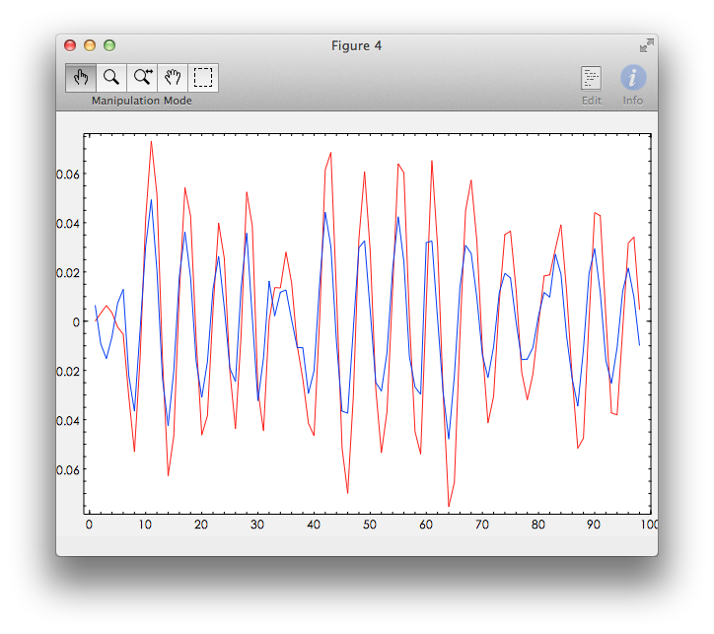

Figure 3.1 Comparison between the responses of estimated model and real model

We can see from the result, at first these two curves have a bigger error, and then they got almost the same, the error is very small.

## Control design

Calculate feedback control designs as:

$$R\left(q^{-1}\right)u\left(k\right)=-S\left(q^{-1}\right)y$$

For the two system configurations down and up, such that the closed-loop characteristic polynomial becomes:

$$AR+BS=A_{c}$$

1. Choose $A_{c}=1$ with design based on calculated model (Problem 1a).

As we known the result we have calculated in problem 1a):

$$H\left(q^{-1}\right)=\frac{-0.8034q^{-1}+0.8034q^{-2}}{1-1.0452q^{-1}+0.9048q^{-2}}$$

So $A=[1,-1.0452, 0.9048]$ and $B=[0,-0.8034, 0.8034]$.

Then we can get:

$$R=\left[1,0.1635\right], S=[-1.0976,-0.1841]$$

1. Choose $A_{c}=1$ with design based on calculated model (Problem 2a).

As we known the result we have calculated in problem 2a):

$$G \left(q^{-1}\right)=\frac{-0.7723q^{-1}+0.7463q^{-2}}{1-0.9809q^{-1}+0.9135q^{-2}}$$

So $A=[1,-0.9809, 0.9135]$ and $B=[0,-0.7723, 0.7463]$.

Then we can get:

$$R=\left[1,3.7058e-2\right], S=[-1.2222,-4.5360e-2]$$

1. Choose $A_{c}=1$ with design based on calculated model (Problem 1b).

As we known the result we have calculated in problem 1b):

$$→H\left(q^{-1}\right)=\frac{1.1150q^{-1}-1.1150q^{-2}}{1-2.9172q^{-1}+0.9050q^{-2}}$$

So $A=[1,-2.9172, 0.9050]$ and $B=[0,1.1150,-1.1150]$.

Then we can get:

$$R=\left[1,-2.0005\right], S=[4.4219,-1.62374]$$

1. Choose $A_{c}=1$ with design based on calculated model (Problem 1b). And move all the pole to the position can minimize ${\left\|S_{y}\right\|}_{∞}$

As we known the result we have calculated in problem 1b):

$$→H\left(q^{-1}\right)=\frac{1.1150q^{-1}-1.1150q^{-2}}{1-2.9172q^{-1}+0.9050q^{-2}}$$

So $A=[1,-2.9172, 0.9050]$ and $B=[0,1.1150,-1.1150]$.

The result is shown in figure 4.1.

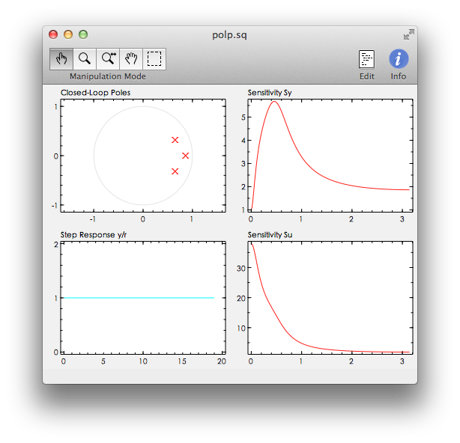

Figure 4.1 Polp figure

Then we can get:

$$R=\left[1,-1.0309\right], S=[1.6050,-0.4333]$$

## Implementation and evaluation

1. Down a

From 4a), I already get the result that:

$$R=\left[1,0.1635\right], S=[-1.0976,-0.1841]$$

So the feedback should be:

$$\left(1+0.1635q^{-1}\right)u\left(k\right)=-(-1.0976-0.1841q^{-1})y(k)$$

$$→u\left(k\right)=-0.1635u\left(k-1\right)+1.0976y\left(k\right)+0.1841y(k-1)$$

So, we can get the change the code as:

u = -0.1635*u_o + 1.0976*y + 0.1841*y_o;

The signal figure is shown is figure 5.1. (The Sysquake file is *PendulumDamp_5a.sq* in the attachments)

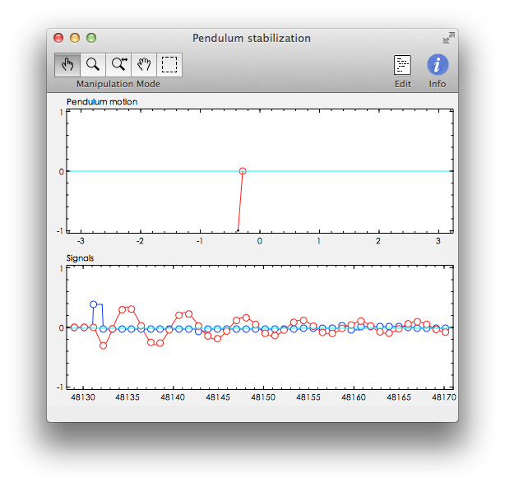

Figure 5.1 Pendulum model with $R=\left[1,0.1635\right], S=[-1.0976, -0.1841]$

1. Down b

From 4b), I already get the result that:

$$R=\left[1,3.7058e-2\right], S=[-1.2222,-4.5360e-2]$$

So the feedback should be:

$$\left(1+0.037058q^{-1}\right)u\left(k\right)=-(-1.2222-0.045360q^{-1})y(k)$$

$$→u\left(k\right)=-0.037058u\left(k-1\right)+1.2222y\left(k\right)+0.045360y(k-1)$$

So, we can get the change the code as:

u = -0.037058*u_o + 1.2222*y + 0.045360*y_o;

The signal figure is shown is figure 5.2. (The Sysquake file is *PendulumDamp_5b.sq* in the attachments)

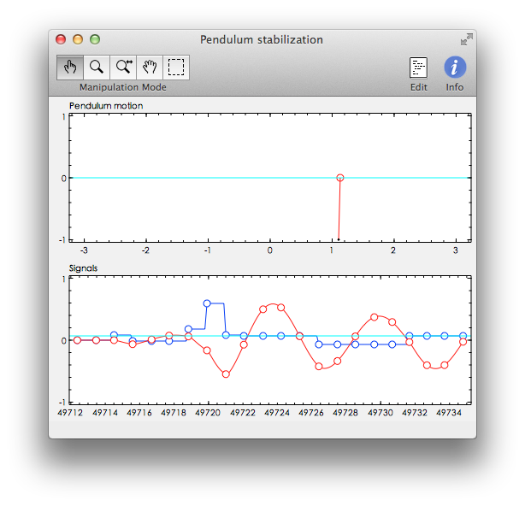

Figure 5.2 Pendulum model $R=\left[1,3.7058e-2\right], S=[-1.2222, -4.5360e-2]$

1. Up a

From 4c), I already get the result that:

$$R=\left[1,-2.0005\right], S=[4.4219,-1.62374]$$

So the feedback should be:

$$\left(1-2.0005q^{-1}\right)u\left(k\right)=-(4.4219-1.62374q^{-1})y(k)$$

$$→u\left(k\right)=2.0005u\left(k-1\right)-4.4219y\left(k\right)+1.62374y(k-1)$$

So, we can get the change the code as:

u = 2.0005*u_o - 4.4219*y + 1.62374*y_o;

The signal figure is shown is figure 5.3. (The Sysquake file is *PendulumDamp_5c.sq* in the attachments)

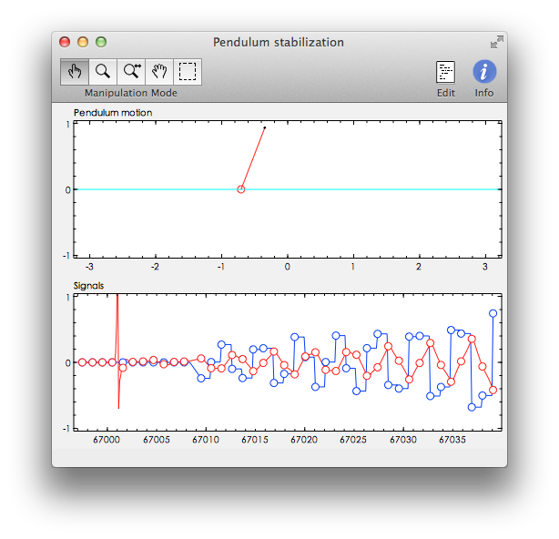

Figure 5.3 Pendulum model $R=\left[1,-2.0005\right], S=[4.4219,-1.62374]$

1. Up b

From 4d), I already get the result that:

$$R=\left[1,-1.0309\right], S=[1.6050,-0.4333]$$

So the feedback should be:

$$\left(1-1.0309q^{-1}\right)u\left(k\right)=-(1.6050-0.4333q^{-1})y(k)$$

$$→u\left(k\right)=1.0309u\left(k-1\right)-1.6050y\left(k\right)+0.4333y(k-1)$$

So, we can get the change the code as:

u = 1.0309*u_o - 1.6050*y + 0.4333*y_o;

The signal figure is shown is figure 5.4. (The Sysquake file is *PendulumDamp_5d.sq* in the attachments)

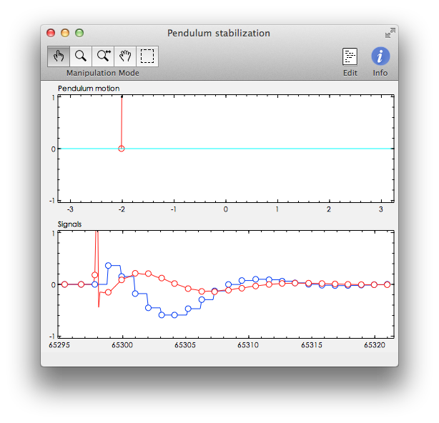

Figure 5.4 Pendulum model $R=\left[1,-1.0309\right], S=[1.6050,-0.4333]$

We can see that the Dead-beat tuning controller for ‘Down’ works well, oscillates didn’t take a long time until get balance. But the Dead-beat tuning rules for ‘Up’ works not so good, we can from figure 5.3 it is unstable. Comparing with the Dead-beat tuning method, the tuning method based on the sensitivity function performs much better. We can see from figure 5.4 that the system is stable and can reach the balance state much faster.